**DAILY ONLINE ACTIVITIES SUMMARY**

|  |  |  |  |  |  |  |
| --- | --- | --- | --- | --- | --- | --- |
| **Date:** | **08-07-2020** | | | | **Name:** | **Likhitha.M** |
| **Sem & Sec** | **6th Sem ‘A’** | | | | **USN:** | **4AL17CS046** |
| **Pre-placement Training Summary** | | | | | | |
| **Subject** | | Cloud and Infrastructure Management | | | | |
| **Max. Marks** | | **-** | **Score** | | | **-** |
| **Coding Challenges** | | | | | | |
| **Problem Statement:**  Write a Java program to push zeroes to End of array | | | | | | |
| **Status:Completed** | | | | | | |
| **Uploaded the report in Github** | | | | **Yes** | | |
| **If yes Repository name** | | | | [**https://github.com/likhithaMantaral/Daily-status**](https://github.com/likhithaMantaral/Daily-status) | | |
| **Uploaded the report in slack** | | | | **Yes** | | |

Online Test Details:

-

Online Training Details:

Attended Cloud and Infrastructure Management Classes which was conducted from 9:30 to 11am.

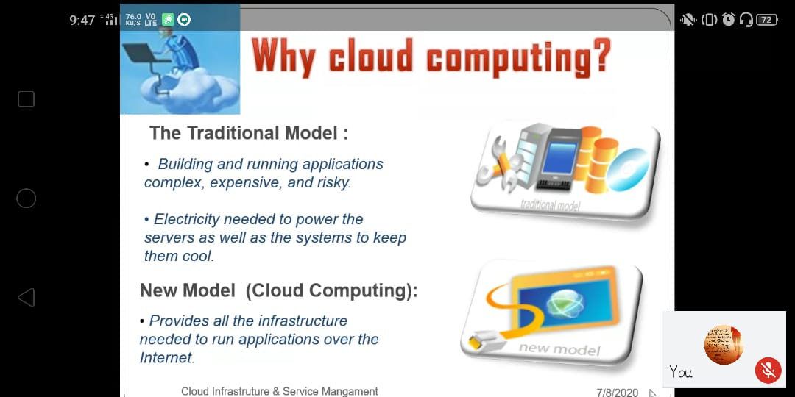

Coding Challenges Details:

Write a Java program to push zeroes to End of array

